***UI/UX Design***

***Figma Link:***

[https://www.figma.com/design/0l7nlWj3V34KCIq3flgO7T/HCI?node-id=18-2&t=QTeJqJP276uRweNd***-***0](https://www.figma.com/design/0l7nlWj3V34KCIq3flgO7T/HCI?node-id=18-2&t=QTeJqJP276uRweNd-0)

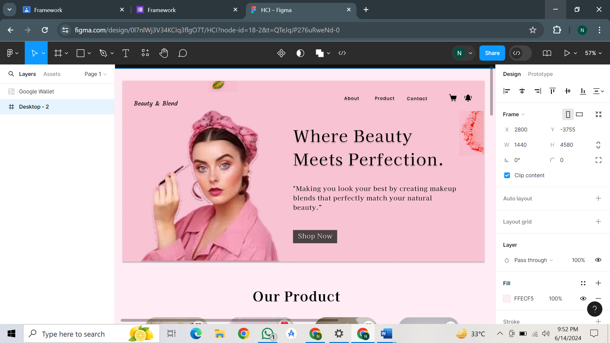

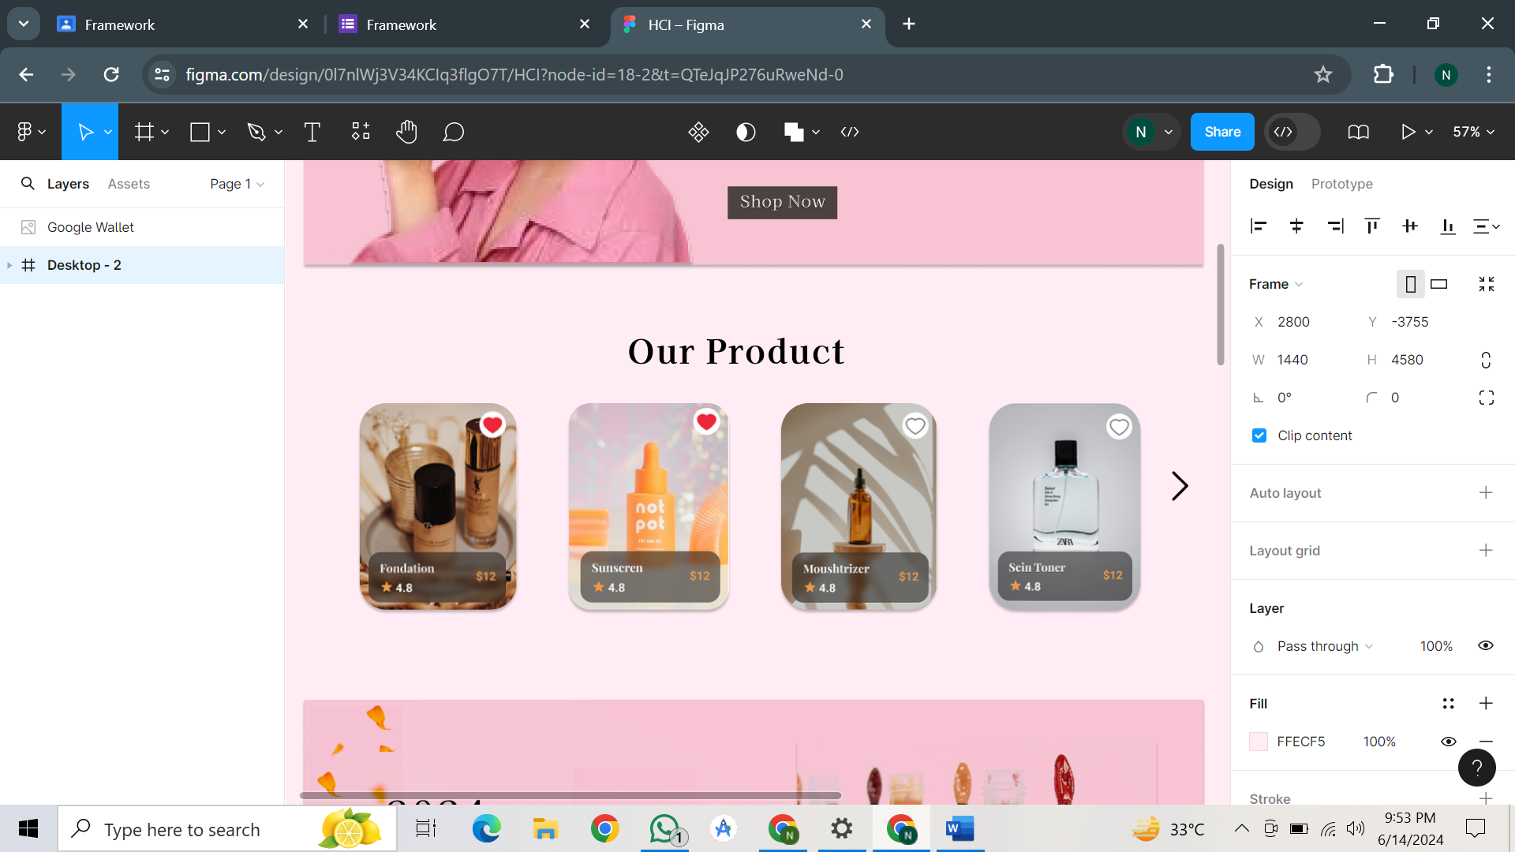

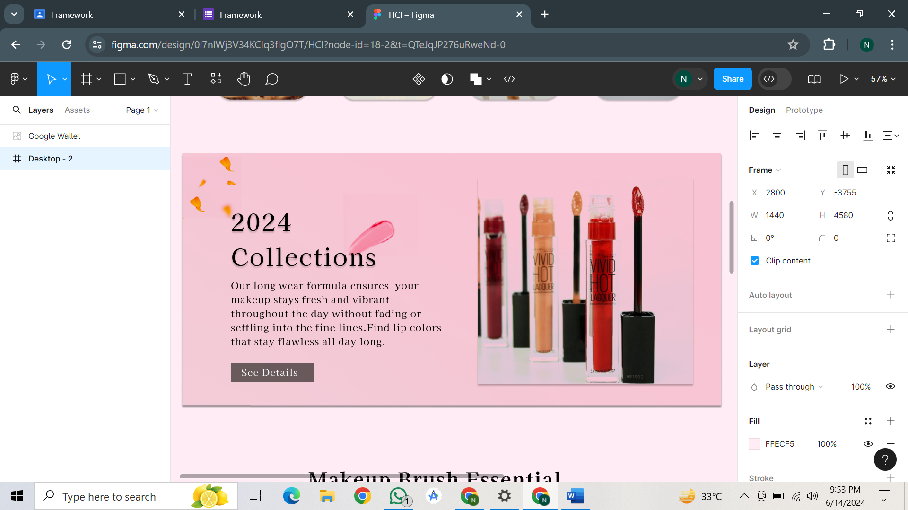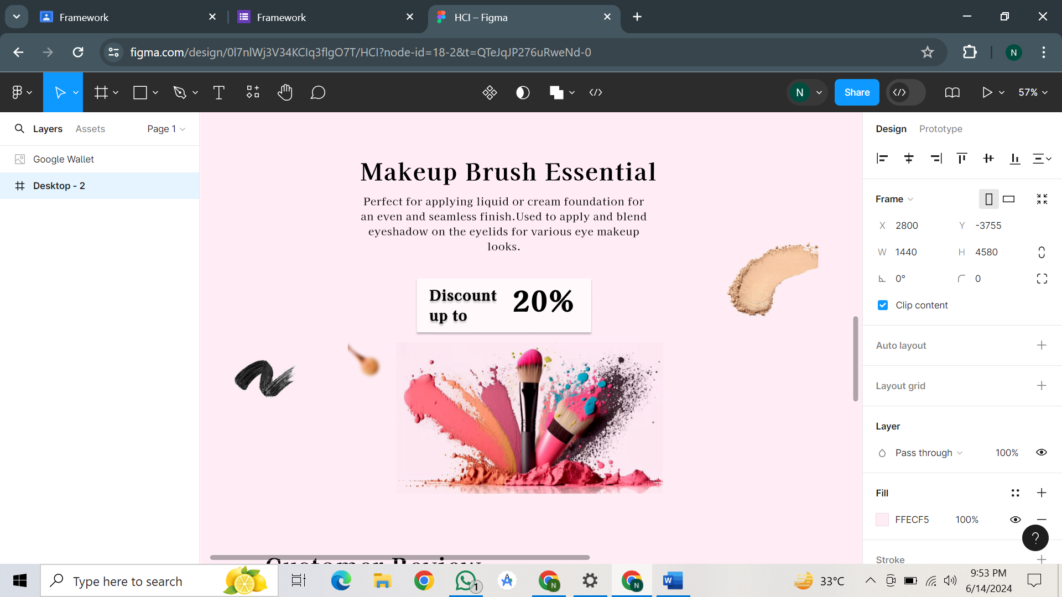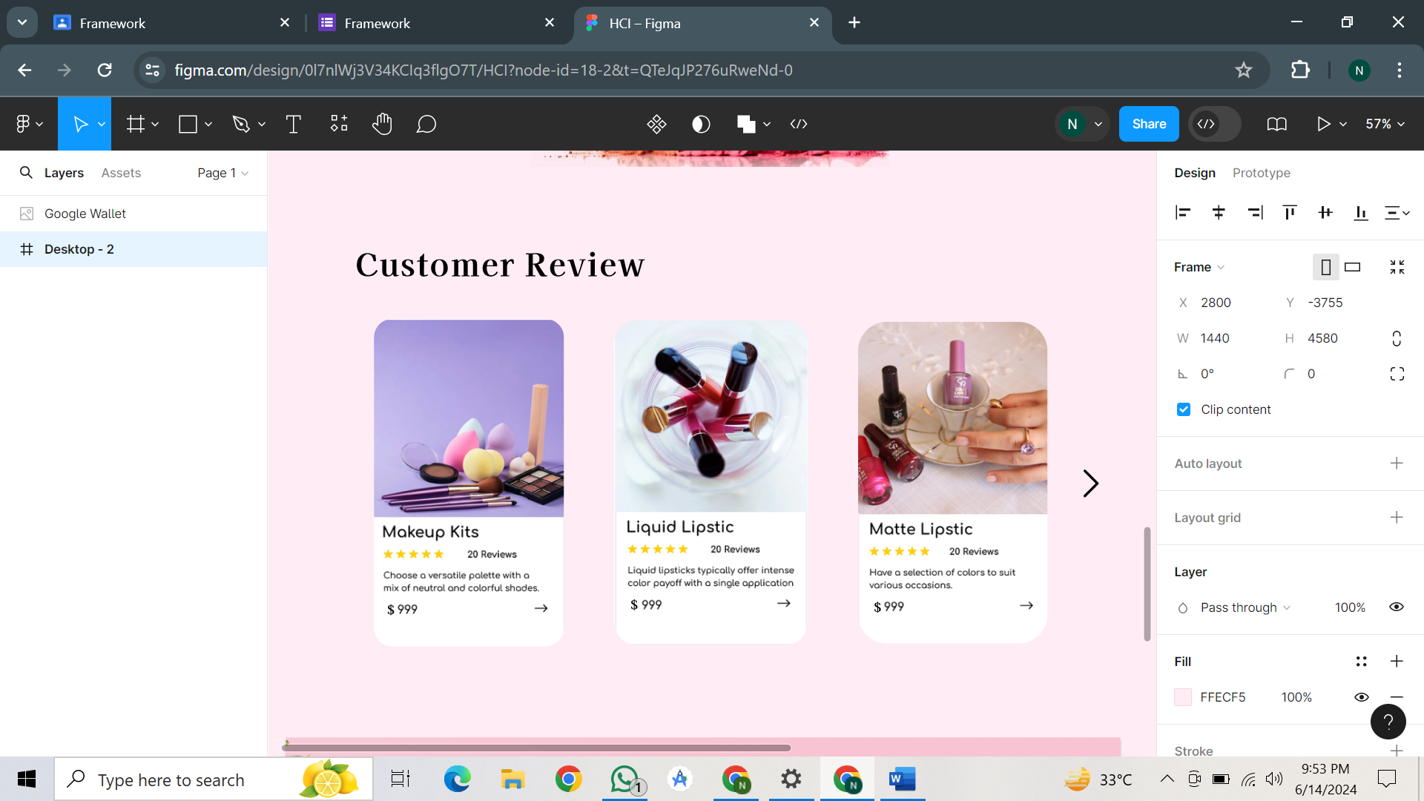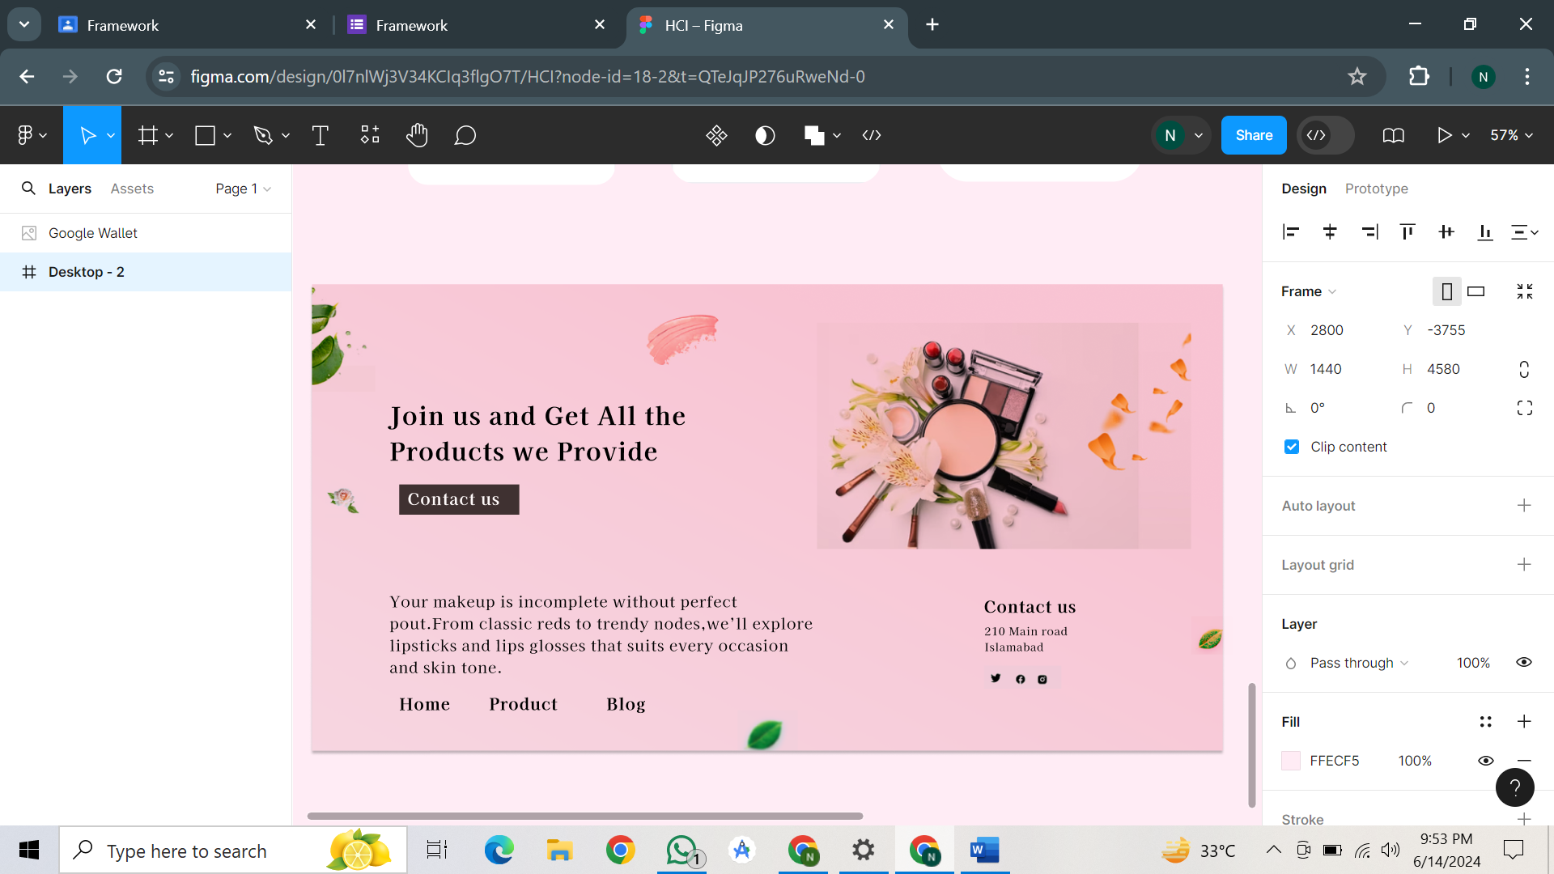

***Completed***